REPORT ON THE SECOND STAKEHOLDERS MEETING FOR THE CONTINUOUS PROFESSIONAL DEVELOPMENT IN UGANDA
HELD AT SUNSET HOTEL JINJA
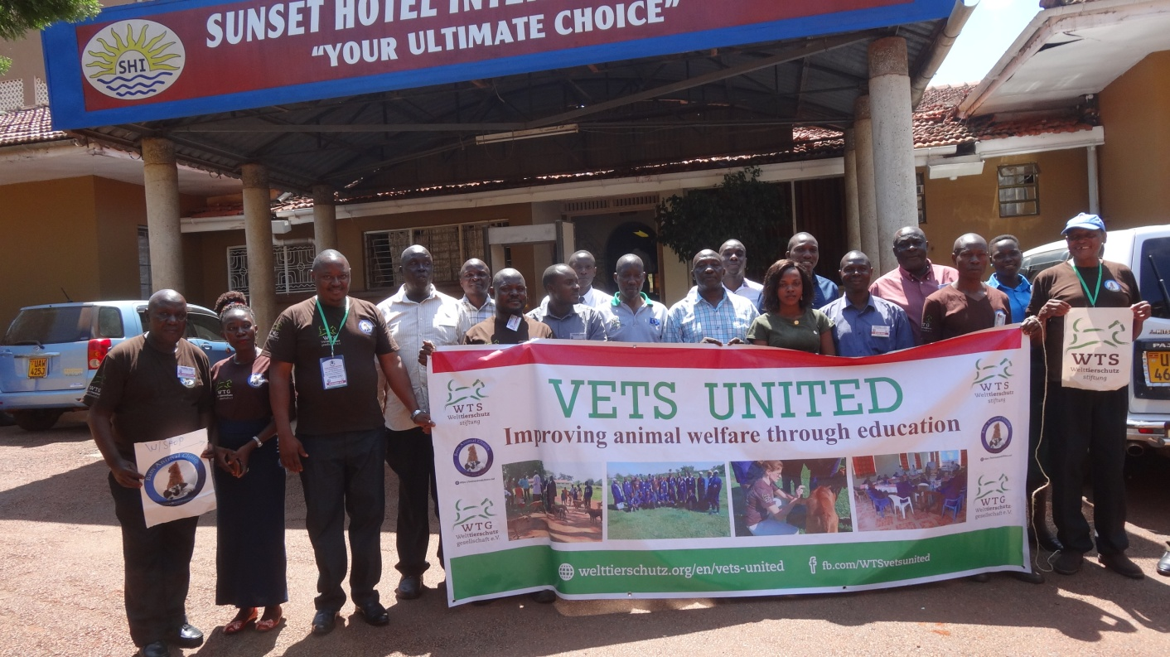
DURATION 26TH TO 27TH NOVEMBER 2019

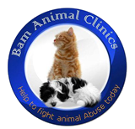
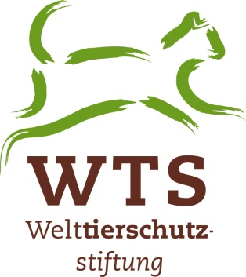
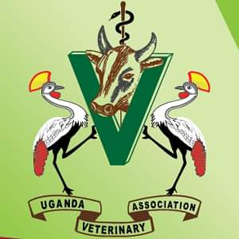

LIST OF ABBREVIATIONS
CPD- Continuous Professional Development
MAAIF- Ministry of Agriculture, Animal Industry and Fisheries
COVAB- College of Veterinary medicine, Animal resources and Biosecurity
UVA- Uganda Veterinary Association
UVB- Uganda Veterinary Board
UVPPA-United Veterinary Paraprofessional Association
VPPs- Veterinary Para Professionals
FAO- Food and Agricultural Organization
BAM- Bam Animal Clinics
WTG- Welttierschutzgesselschaft
WTS- Welttierschutzstiftung
OIE- World Animal health Organization
OPM- Office of the Prime Minister
NGO- Non Government Organization
Vet- Veterinary
Vets- veterinarians
CAO- Chief Administrative Officer
DVO- District Veterinary Officer
VO- Veterinary Officer
TOTs-Trainers Of Trainees
PS – Permanent Secretary
CAH- Commissioner Animal Health
ACVRE- Assistant Commissioner Vet Regulation and Enforcement

TABLE OF CONTENTS:
COVER PAGE……………………………………………………………….……….i
LIST OF ABBREVIATIONS………………………………………...........…..…….ii
TABLE OF CONTENT………………………………………………..............……iii
EXECUTIVE SUMMARY……………………………………...…………….……..v
DAY ONE…………………………………………………………………….…..……1
PRESENTATION FROM DIRECTOR……………………………….………….….1
TABLE 1 SHOWING LIST OF PARTICIPANTS IN BUY-IN MEETIN..….…….2
SUMMARY OF ToTs………………………………………………………………….3
MILESTONE…………………………………………………………………………...4
REACTIONS…………………………………………………….……………………..5
RESPONSES……………………………………………………….………………...…5
PREVIOUS RESOLUTIONS AT STAKEHOLDERS' MEETING………………..6
REACTIONS………………………………………………………….………………..8
PRESENTATION OF THE CPD LOGIC MODEL…………………………………8
PICTURE 1 SHOWING THE LOGIC MODEL…………………………………….9
DESCRIPTION OF THE LOGIC MODEL………………………………………….9
DISCUSSIONS AND REACTIONS………………………………………..…………11
PRESENTATION OF METHODOLOGY…………………………………………...12
REACTIONS…………………………………………………………………………….14
RESPONSES……………………………………………………………………..………14
PRESENTATION OF ISSUES RAISED BY ToTs………..…………………………..14
REACTIONS……………………………………………………………..………………15
INTERPRETATION OF THE FEEDBACKS SUMMARY…………………………..16
PICTURE 2 SHOWING THE INFOGRAPHIC-DRAFT OF ToTs………………….16
REACTIONS…………………………………………………………….……………..17
DAY TWO………………………………………………………………………………18
RECAP OF DAY ONE…………………………………………………………………18
GROUPWORK ON TOPICS & CONTENT FOR TRAINING OF TRAINEES…..20
CONCLUSIONS…………………………………………………………………………22
TABLE 2 SHOWING THE COURSE CONTENT OF TRAINEES…………..……..23
BEST WAYS TO IMPROVE ANIMAL WELFARE CPD TRAININGS IN UGANDA……………………………………………………………………….………..24
REACTIONS AND DISCUSSIONS……………………………………………..…….25
SUMMARY OF KEY POINTS………………………………………………………..26
DISCUSSION ON HOW TO ALLOCATE CREDIT POINTS…………………….26
SIGNING OF MoU………………………...................................................…………..26
CLOSING REMARKS………………………………………………….……………..27
APPENDIX I…………………………………………………………………………………….27
APPENDIX II …………………………………………………………...……………..28.

EXECUTIVE SUMMARY
The second stakeholders meeting held from 26th to 27th of November, 2019 at sunset hotel Jinja was successful and achieved all its objectives.
The meeting was officially opened by the director of Bam animal clinics; Dr. David Balondemu, attended by representatives from UVA, UVB, UVPPA, COVAB, veterinary inspectors of selected zones and Bam Animal Clinics staff.
The meeting was aimed at BAM animal clinics presenting activities done and actions taken during the pilot CPD program conducted in the selected pilot zones 1 and 2 respectively. The specific objectives were;-
- To relook into the pervious resolutions at the Buy-in stakeholders meeting which was held at sunset hotel Jinja from 6th to 7th June 2019.
- To discuss the key issues which were raised by trainees (TOTs) in their feedbacks, during the 3 days trainings that took place in the 2 pilot zones, zone 1 and 2, from 13th to 15th August 2019 at Sana hotel Iganga district and 14th to 17th October 2019 at ivory hotel Nansana Wakiso district respectively.
- To agree on the topics to include in the CPD curriculum for the training of trainees.
- To agree on the best ways to improve animal welfare cpd training on long run and the sustainability of the project.
- To allocate credit points to the agreed cpd curriculum/Topics.
Discussions on the presentations were open and critical in which several views and ideas were developed. For more generation and discussion of key issues, participants were divided into groups in which questions leading to conclusions and way forward were thoroughly discussed.
By the end of the meeting participants resolved that the CPD curriculum should be well tailored to the Uganda conditions to address the challenges concerning welfare of animals and also resolved that the Topics to be included in the curriculum should include Concepts and principles and Definitions of animal welfare, Animal Welfare Basics 1, Animal Welfare Basics 2, Animal welfare during transportation, and slaughter and that trainees should also be inform of the legislation and enforcement on animal welfare, and a summary of the course content was presented.
The meeting also made key recommendations on the possible sustainability plans for the CPD program which included:

- Planning as very important for sustainability of the project.
- Logistics like finances and other materials needed.
- UVB’s continued evolvement in the trainings.
- Progress reports be provided time to time.
- Needs assessment before training in a particular area be carried out.
- Relating animal welfare to people’s income needed to be emphasized.
- Methodology needed be updated to suit the trainings needs.

The meeting involved presentations and discussions on key topics earmarked in the program.
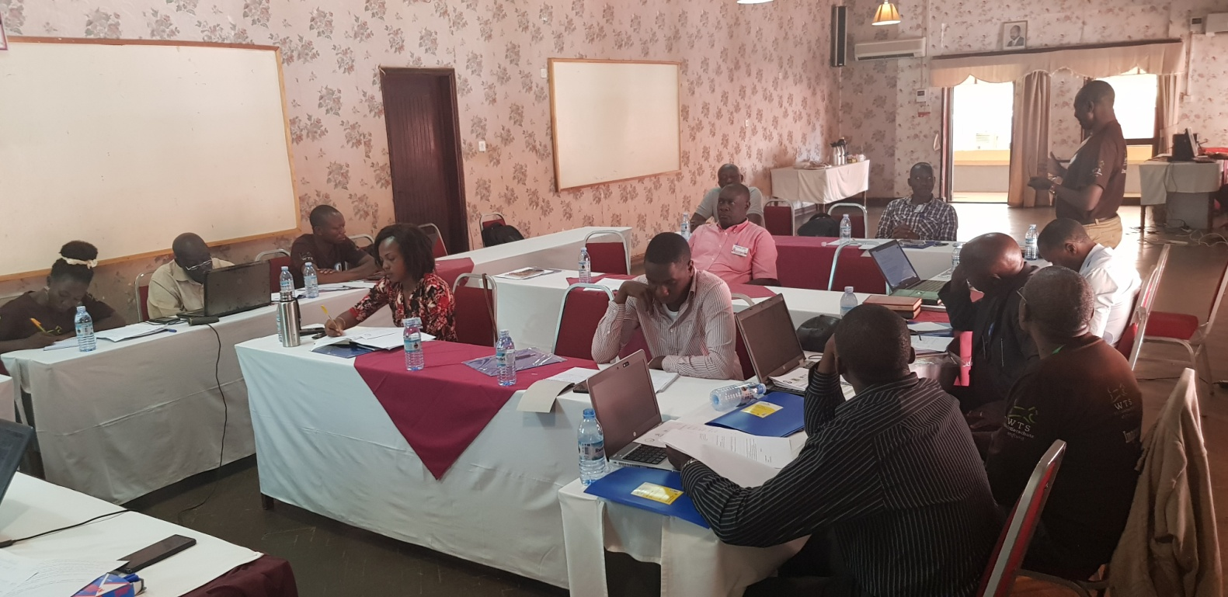
The meeting was closed by the chairman Bam Animal Clinics Mr. Kasango Christopher David and the Director Mr David Balondemu.
DAY ONE
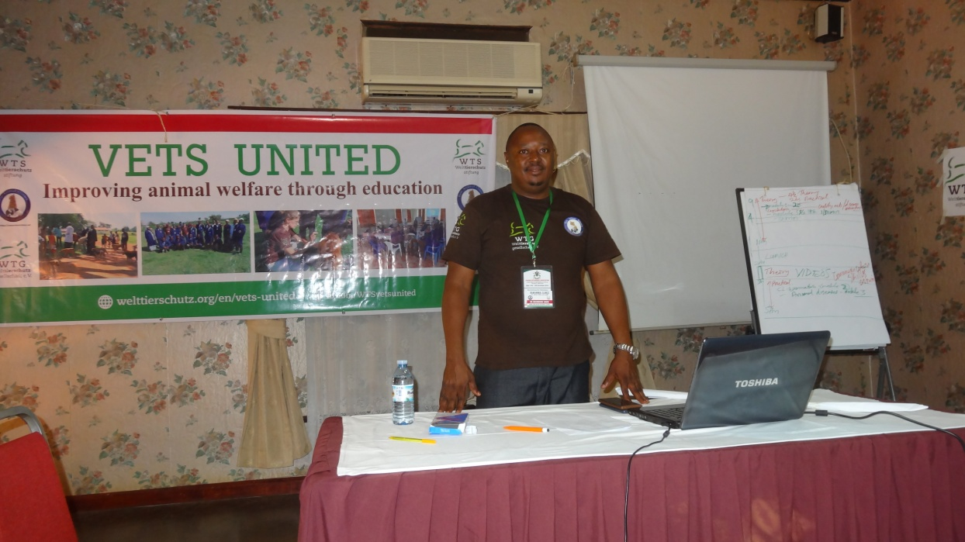
PRESENTATION FROM THE DIRECTOR BAM ANIMAL CLINICS.

Presentation by Mr David Balondemu
Mr David Balondemu welcomed all the stakeholders from UVA, UVB, MAAIF, and UVPPA among others and read through the program of the meeting.
He gave a brief history about Bam charity organization, its goals and objectives.
He also briefed members about Bam development partners and CPD sponsors the WTS-Vets united of Germany, their Goals, missions and objectives.
PROJECT THEME: IMPROVING ANIMAL WELFARE AND HEALTH THROUGH CONTINOUS PROFFESSIONAL TRAINING OF VETERINARIANS AND VETERINARY PARAPROFESSIONALS IN UGANDA (CPD).
The Director informed the members that the project started on 1st May 2019, with the stakeholders buy-in meeting which was held at Sunset Hotel Jinja 6th to 7th June 2019, and presented the overall report of the first stakeholders meeting and the 2 ToTs trainings.
He said the buy-in meeting was aimed at Bam animal Clinics presenting the proposed work plan to stakeholders and actors for the pilot CPD program for the selected areas of South Eastern zone and Central zone 2. The specific objectives were to introduce, discuss, harmonize and agree on the topics to be included in the CPD curriculum for Trainers of trainees, to allocate credit points to the agreed CPD curriculum, to agree on the certificate format/design to be awarded to attendees, to discuss the sustainability plan for the project after the pilot phase. Participants were also informed of the roll-out plan indicating locations and period.
He said the presentations during the meeting included: Background of Bam animal clinics; Background of WTS Vets-United program, proposed work plan for the implementation of the CPD project and the Vets-United Online resource.
He presented a list of all members who attended the buy-in meeting, their representatives and designations as below.
Table 1: Showing the List of Participants who attended the buy-in meeting.
NAME | DESIGNATION | DEPARTMENT
DR. BALUKA SYLIVIA | PRESIDENT | UVA
DR. BUSUULWA HENRY | PRESIDENT | UVPPA
DR. GABRIEL TUMWINE | LECTURER | MAK.COVAB
DR. KALANGE MUHAMUD | AW(OUTREACH) | BAM
DR. WESONGA W S N | DIRECTOR | AWPO/BAM
DR. KAGODA SAMUEL | AW/LAB EXPERT | BAM
DR. ROBERT OJALA | VETERINARY INSPECTOR, ZONE 1 | MAAIF
DR. MULINDWA TANANSI | V.I FOR COMMISSIONER | MAAIF(DAR)
DR. HIGENYI JAMES | VETERINARY INSPECTOR, ZONE 2 | MAAIF
DR. JOSEPH OUMA | EXECUTIVE MEMBER | UVA
DR. SSUNA PAUL | SNR. SURGEON | BAM
DR. DOMINIC MUNDRUGO LALI | C/M EDUCATION COMMITTEE | UVB
MR BALONDEMU DAVID | DIRECTOR | BAM
NAKABUYE ROBINAH | RAPPARTOUR | BAM

He then informed the members that Bam animal clinics had carried out the trainings i.e Training of Trainers (TOTs) as per the project plan and he read out a summary of the whole training period.

Summary of ToTs training;
Training was held in two selected pilot project zones ie South Eastern zone consisting 14 districts and Central Zone ll 9 Districts.
South Eastern zone :
The Director said the training was held from the 13th to 15th August 2019 at Sana Country Hotel Iganga, and this preceded an earlier Buy-in meeting held in June which was conducted in line with the agreed recommendations.
He said the training targeted DVOs, VOs and veterinary paraprofessionals in the South Eastern zone of Uganda covering 14 Districts and 28 participants were selected, 2 from each district.
He said the first TOTs training was attended by; UVA president Dr Sylvia Baluka, the UVB chairman Education committee Dr Lali Mundrugo, the veterinary inspector south eastern zone Dr Ojara Robert, the UVPPA president Mr Busulwa Henry, the District production officer Mr Dhikusoka, Dr Baligeya the host DVO and other invited guests.
The theme of the training was;
IMPROVING ANIMAL WELFARE AND HEALTH BY CAPACITY BUILDING THROUGH CONTINOUS TRAINING OF VETERINARIANS AND VETERINARY PARAPROFESSIONALS IN UGANDA (CPD) ON LONG TERM.
The topics trained included;-
- Adult learning principles and teaching skills,
- Animal welfare concepts and care,
- Animal welfare legislation ,
- Animal husbandry
- The Five freedoms and their provisions.
- clinical examination and
- Humane handling and, had several practicals on several animals like dogs, cattle, sheep/goats and camels/Donkeys.
The training involved several discussions between the facilitators and participants where participants shared knowledge and made inquiries on different areas of concern in Animal Welfare.
Mr. David Balondemu informed the members that the training was sponsored by WTS Vets- United of Germany and organized by BAM Animal Clinics under the supervision by the UVB representatives, the UVA, UVPPA plus MAAIF Representatives.
Central Zone ll :( TOT 11)
Training held at: Ivory Hotel Nansana Wakiso District from the 15th to 17th .Oct. 2019.
Under the same theme, the training Covered 9 Districts with 18 participants selected, 2 from each District.
The training involved several discussions between the facilitators and participants, where participants shared knowledge and made inquiries on different areas of concern in Animal Welfare, Legislations and Clinical Diagnoses among others.
Informed members the training was sponsored by WTS Vets-United of Germany and organized by Bam Animal Clinics under the supervision of the UVB and the UVA, MAAIF and the Chief Guest was Dr Lali Mundrugo a representative UVB. Other guests were; MAAIF Central zone ll inspector Dr Higenyi James and Mrs. Namuleme Aida, the vice chairperson UVPPA.
The Milestone;
- Preparation for Buy in Meeting in May 2019 was done successfully by Bam animal clinics management.
- The buy in meeting was successfully held in June 6thto 7th 2019 with 100% turn-up.
- M&E framework and the logic model were well developed by Natascha for guiding project direction.
- Discussed a bit of the long term ideas of self-sustainability and discussed how ToTs were to be selected.
- Bam had a number of trainers and by July they were readily available to take on training as assigned.
- The training of trainers (ToTs) was done in August and October 2019 and a total of 46 participants successfully went through our training and were awarded with Certificates.
He told the members that participants were then ready to train others in animal welfare using the WTS Vets-United training resource and materials.
He acknowledged that Bam animal clinics was so grateful to the partners ie the WTS Vets-united, who availed it with funds in the right time and that everything went on smoothly as planned.
Thanked all the stakeholders for turning-up for the meetings plus the subsequent follow ups during the ToTs trainings.

REACTIONS
Mr Busulwa Henry
Thanked bam for the good work done in the two selected pilot zones and for making sure another stakeholder meet is convened.
He emphasized the supervision of UVB since it is the overall body for all veterinarians in the country.
Suggested that atleast reports should be distributed among the relevant stakeholders specifically UVB as well.
Dr Higenyi James
Suggested that BAM should emphasize things that made the training a success, considering the challenges faced during the training.
Advised that UVB logos should be included on the training materials to give a picture that Bam Animal Clinics is under its supervision.
Dr Tayebwa Dickson
Urged that challenges and issues raised by the participants during TOTs training should be considered as participants were looking forward on how best to improve the CPD program e.g involvement of politicians, need for more materials, Lab equipments at Districts, and more surgeries especially at Vets level.
RESPONSE
Mr David Balondemu responded that the challenges were stated together with the issues raised by participants in the feedback forms and were to be presented and discussed in the meeting.

PRESENTATION ON THE PREVIOUS RESOLUTIONS AT STAKEHOLDERS MEETING AT SUNSET, JUNE 2019
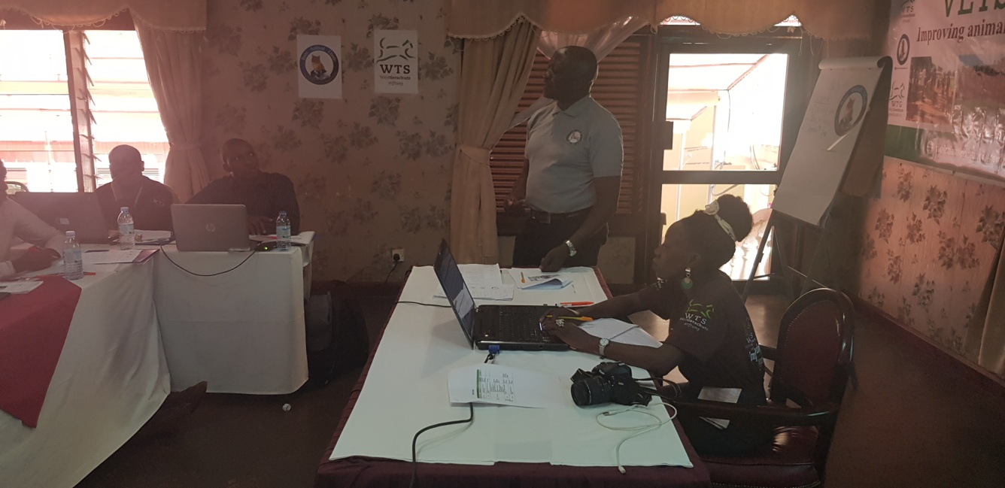

Presentation by MR. BUSULWA HENRY.
He started by asking how many members were there in the first meeting since other members were represented.
He emphasized that the rapporteur should be very keen and consistent with the dates and numbering of the reports made.
He then advised that the report should start with the executive summary ie a brief of what transpired during the period since most people at times do not have much time to read the whole report.
He also ought to know whether what was resolved in the executive summary had been implemented. “By the end of the meeting participants resolved that the CPD curriculum should be well tailored to the Uganda conditions to address the current challenges concerning proper welfare of animals.” and said that since they were resolutions, wanted to know whether they were being implemented.
He said that the meeting also made recommendations like lobbing of the CPD program in the local government district Budget by the DVOs and asked whether the DVOs had included the recommendations of the training as to their planning in capacity building and suggested that they should lobby for inclusion of CPD programs while planning for capacity building in their departments.
He said the program should stretch down to Para professionals and asked if BAM had included it to its planning and urged members to ask BAM and vets united for backups on the CPD program.
The allocation of credit points, he requested Dr Lali to clarify and that UVB should give the exact points and how many hours to be accredited for how many points since they had suggested that one contact hour was equivalent to one credit point and added that every VO should register with UVB.
From the reactions of the previous meeting, he said that the attitude and aptitude were more of the things that needed to be considered during the trainings.
He asked whether anyone had gone ahead and explained to the ministry about what has been done to the animal sector giving examples of the practicals done by VOs at schools and the outcomes in the field, technical personnel (drug usage and warnings on expired drugs), transportation (over loading), and their compliance with the law and suggested that members should share experiences to help the trainees to help animals during emergencies and disasters.
He reminded the members that all Veterinary professionals took oaths upon graduation to uphold welfare, health and rights of all animals and congratulated UVB and other stakeholders for participation in the symposium.
He also added that vets requesting for transport from the farmer before taking action was still a challenge.
Incorporation of the CPD curriculum, he suggested that Dr Lali should follow it up to the ministry.
He also said that members suggested that trainings should be done in various districts and that quiz should be given out to assess the impact of training.
About Sustainability strategies, He said that members suggested that districts should play a big role in the CPD program.
He then suggested that expectations should be included in the curriculum.
Asked when will the training start for the trainees ,who will pay for the training expenses and who will lead the training process.

REACTIONS
Mr David Balondemu: said that presentations included plan how the trainings were going to be done and backstopped and will all be subjected to scrutiny by the members in the meeting.
He informed the members that the training of trainees is to start in April 2020 and that all costs will be handled by WTS Vets- united for this pilot project of 2 years and added that no funds will be requested from the participant.
Dr Tayebwa Dickson: DVOs should be notified on what topics were to be trained on at the time of training to enable them prepare well in time.
Dr Kalange M added that BAM management hoped that UVB would help in the selection criteria; we suggested DVOs and VOs from each district since they have the capacity to plan for their departments in the districts.
He also said that BAM suggested that UVB and its representatives should join the trainings because it is in their mandate for quality assurance and assessment.
Mr Kagoda Samuel: supplemented that other members like Para- professionals were also included in the training.
Dr Ojara Robert: suggested that members should perfect themselves in animal welfare since there were many concepts to be tackled.
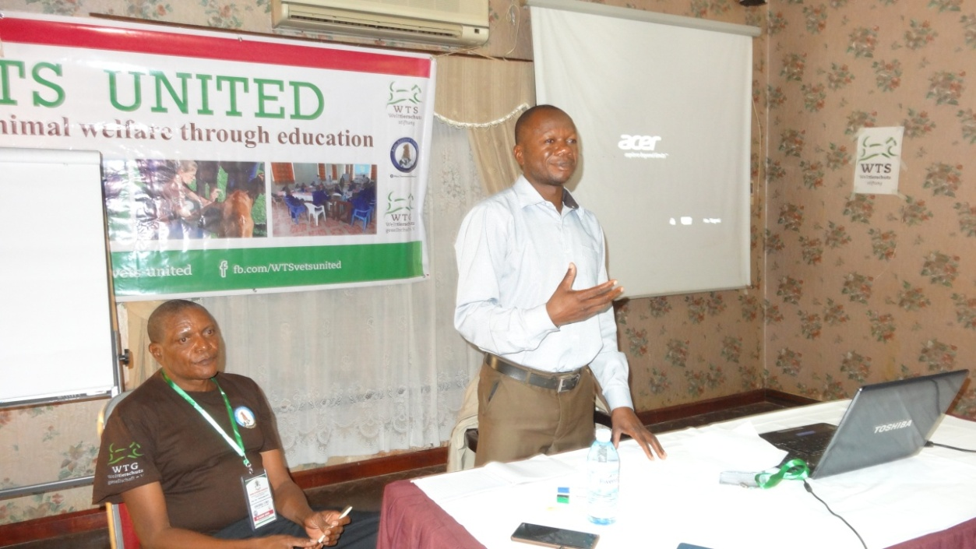
PRESRNTATION OF THE CPD LOGIC MODEL

Presentation by DR KALANGE MUHAMOUD
He started by saying that the model was designed as a model suggestion.
Dr Kalange presented about the Logic model designed by Natascha at the WTS. He started by outlining the various stages of the model under the main headlines; Situation analysis, Activity/Outputs, Short-term outputs, Intermediate outcomes and Long term outcomes and finally the ultimate Goal to be achieved.
Picture 1; Showing the logic model.
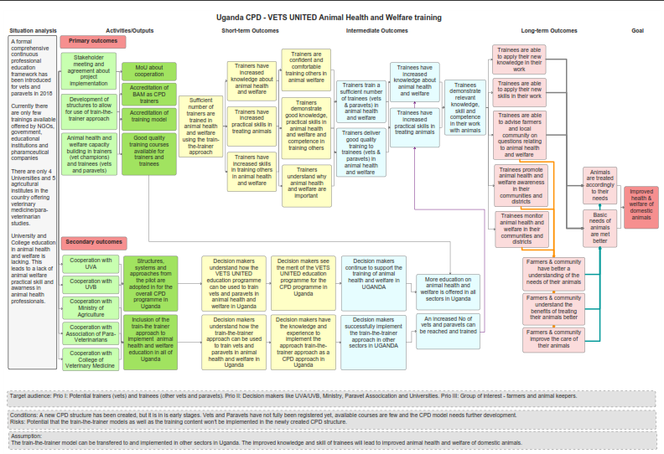
Descriptions:
Situational analysis
CPD framework developed by the UVB since 2018
Currently there are a few trainings taking place and offered by NGOs , Education institutions and pharmaceutical companies.
Uganda is with 4 Veterinary institutions and 5 Agricultural institutions, offering Vet medicines and Paraprofessional studies.
University and Collage animal welfare and health studies are lacking leading to lack of animal welfare practical skills and awareness in animal welfare skills amongst animal health professionals.
Primary activities:
- Stakeholder meeting and agreement about project implementation

- Development of structures to allow for use of train-the-trainer approach
- Animal health and welfare capacity building in trainers(vet champions) and trainees (vets and paravets)
Expectations;
- MOU about cooperation
- Accreditation of BAM as CPD trainers
- Accreditation of training model
- Good quality training topics and modules available for trainers and trainees

Secondary activities

- Cooperation with UVA
- Cooperation with UVB
- Cooperation with Ministry of Agriculture
- Cooperation with Association of Para Veterinarians
- Cooperation with College of Veterinary Medicine
Their expectations;-
- Structures, systems and approaches from the pilot be adopted in for the overall CPD program in Uganda
- Inclusion of the train-the trainer approach to implement animal health and welfare education in all of Uganda.

Short term outcomes for both primary and secondary activities expected were;-
- Sufficient number of trainers to be trained in animal health and welfare using the train-the-trainer approach
- trainers to have increased knowledge about animal health and welfare
- Trainers to have increased skills in training others in animal health and welfare
- Trainers to have increased practical skills in treating animals
- Trainers to be confident and comfortable training others in animal welfare
- Trainers to demonstrate good knowledge, practical skills in animal health and welfare and competence in training others
- Trainers to understand why animal health and welfare are important.
- Decision makers to understand how the VETS-UNITED education program was to be used to train vets and paravets in animal health and welfare in Uganda
- Decision makers to understand how the train-the-trainer approach was to be used to train vets and paravets in animal health and welfare in Uganda
- Decision makers to see the merit of the VETS-UNITED education program for the CPD program in Uganda
- Decision makers to have the knowledge and experience to implement the train-the-trainer approach as a CPD approach in Uganda

Intermediate outcomes for both primary and secondary activities expected were;-
- Trainers to train a sufficient number of trainees (vets& Paraprofessionals) in animal health and welfare
- Trainers to deliver good quality training to trainees (vets & Paraprofessionals) in animal health and welfare
- Trainees to have increased knowledge about animal health and welfare
- Trainees to have increased practical skills in treating animals
- Trainees to demonstrate relevant knowledge, skill and competence in their work with animals
- Decision makers to continue to support the training of animal health and welfare in Uganda
- Decision makers to successfully implement the train-the-trainer approach in other sectors in Uganda
- More education on animal health and welfare to be offered in all sectors in Uganda
- An increased No. of vets and Para-professionals to be reached and trained

Long term outcomes for both primary and secondary activities expected were;-
- Trainees to able to apply their new knowledge and skills in their work
- Trainees to be able to advise farmers and local community on questions relating to animal health and welfare
- Trainees to promote animal health and welfare awareness in their communities and districts
- Trainees to monitor animal health and welfare in their communities and districts
- Farmers & community to have a better understanding of the needs of their animals
- Farmers & community to understand the benefits of treating their animals better
- Farmers & community to improve the care of their animals
- Animals to be treated accordingly to their needs
- Basic needs of animals to be met better

Overall Goal:
To improve health, welfare of domestic and wild animals.

DISCUSSIONS AND REACTIONS:
Dr Ojara Robert; the model should consider the local governments they are major players in the cpd dispensation program.

Dr Kiryabwire David suggested that a topic on productivity should be included in the training modules so that trainees get the relevance of animal welfare and productivity.

Dr Kagoda Samuel; Explained animal welfare relationship with animal health and productivity and said that animal welfare is a state that has to be considered so as to achieve health and productivity.

Dr Higenyi; added that animal rights are absolute and are to be done in favor of the animal, and that animal welfare is something that is to be advocated for, in relation to quality and productivity to achieve our goal.

Mr Busulwa Henry; suggested that although the model is limited by various activities , how the farmer is to benefit should also be included.

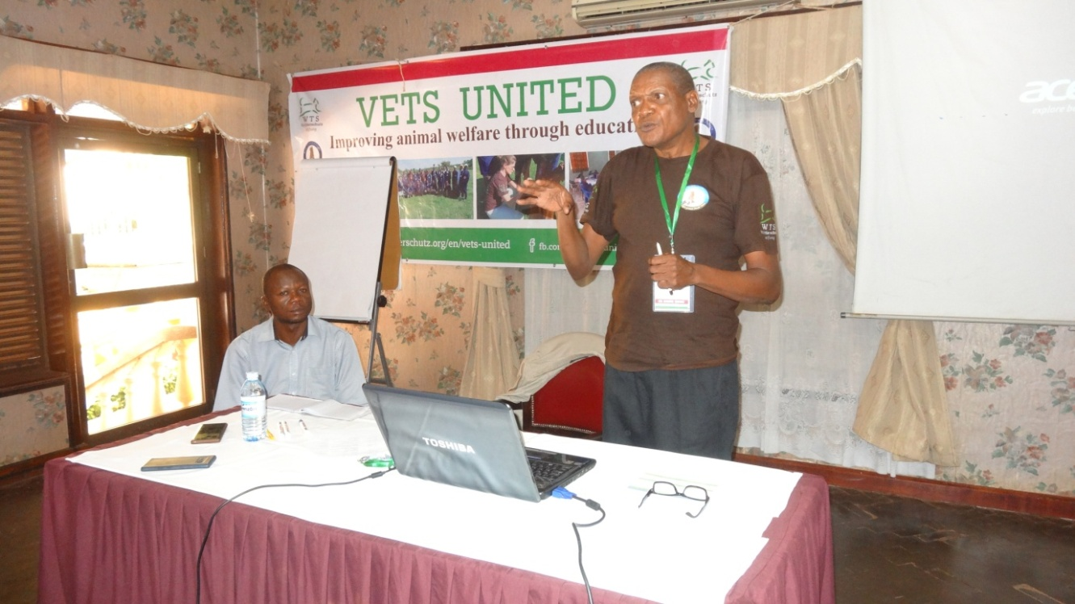
PRESENTATION OF METHODOLOGY by Mr Kagoda Samuel

Mr Kagoda Samuel said the goal of the CPD was to establish regular ongoing CPD training for vets and/ paraprofessionals in the country.
He described how the team was to achieve the goal through what he called “methodology” and the following steps have been since followed:

- Partition the country into different segments (e.g. regions, Zones, districts, sectors etc.)
- Identify important topics which should be included in animal welfare related training (relevant topics from VETS-UNITED resource be selected and as need additional topics added)
- Identify trainers in each segment (decentralized approach)
- Train a trainer in each segment(training should include theory and practice), films
- The trainers then offer regular training for the vets and paraprofessionals in their region

Said the strategy was to train veterinary and Para-veterinary professionals in 2 pilot veterinary zones, the 10 Zones and their districts were listed as per MAAIF 2010 design.
The reasons for the selected pilot zones were that; The selected zones utilise all types of livestock production systems and also found along the major production, transportation, marketing and slaughter of animal routes stretching from the poorest to the fairly economically powered households. Demonstration and enforcement of compliance for the animal welfare and health operations in these critical and important zones will send advocacy and awareness messages to each corner ahead of total rollup in Uganda.
More Zones and districts could be involved after the pilot phase of the project given this brilliant perfomance , he asserted.

Proposed course modules:
Module 1: Concepts and principles and Definitions of animal welfare
Module 2: Animal Welfare Basics1
Module 3: Animal welfare Basics 2
Module 4: Animal welfare specialized
Module 5: Animal welfare during transportation
Module 6: Animal welfare during slaughter
Module 7: Communication and Teaching skills
Outreach / field practices to be conducted on various farms.
Following the selection criteria of trainees, he informed members that the target zones will include; 12 trainings and for each training, 2 (ToTs) vets will be on site as trainers, BAM staff as supervisors, 20 participants will be trained per site, and that selection of participants will emphasize registration with UVB.
He added that there are so many districts to train but others will be merged to cover the 12 trainings, but stake holders will be informed on how the merged districts will be covered when the training time comes.
KEY TIMELINES
End of June 2019:
Stakeholder meeting was carried out
A curriculum is developed for the trainings.
MOU signed

July to December 2019:
First training period: In Both zones of 3days training was carried out.

End of Sept 2020:
Second period of training was carried out in pilot zone districts

End of April 2021:
The CPD training is fully recognized.

REACTIONS
Members suggested that components should be changed to Modules ~ changed.
Members also suggested that the methodology should be changed to suit levels of professionalism.
Mr Busulwa; observed that some districts were not included in the pilot phase even when they are in the region. He gave an example of Nakasongola.
He emphasized that participants to be trained should be registered to UVB and that DVOs should be very keen on the list of trainees submitted and gender balance should be considered.
He urged that members should be consistent with Vet paraprofessionals not Para Vet-professionals.
RESPONSES
Mr Kagoda Samuel informed members that the methodology catered for all professionals for both ToTs and Trainees.
Dr David Balondemu supplemented that Para professionals were included and gave an example of Kween district where one VO was trained and the rest were Paraprofessionals.
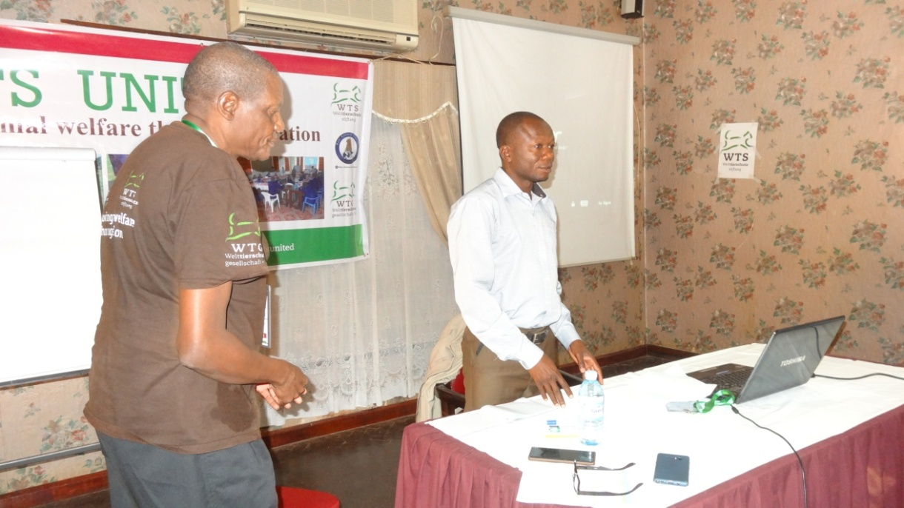
PRESENTATION ON ISSUES RAISED BY TRAINEES (ToTs)

Presentation by Dr Kalange Muhamoud
Dr Muhamudu told the meeting that as a routine practice during our trainings, participants are served with feedbacks so the organizers share with them their attitudes towards the training. These feedbacks are designed by our experienced managers at the WTS Vets-United, and are served at the end of the training. So we gathered all the feedbacks from the two trainings and had several issues raised. We were able to fuse them as some represented similar ideas. Dr Kalange read through the most important 37 issues raised. APPENDIX I.
REACTIONS
Members suggested that we consider the local animal species available in a training area.
Members also agreed that more visual aids should be provided if the service provider has the capability.
Members suggested that MAAIF should take the initiative to elaborate about the laws and penalties for breach of animal welfare regulations.

They also suggested that the ministry should be tasked to provide necessary laboratory equipments and materials at the districts for the trainees to practice.

They added that more surgical kits and protective gear for dog handling and restraint should be provided by service providers, and also to consider surgeries that are relevant for the trainees.

They suggested that BAM should be hard on the resourceful people to train on humane handling, slaughter and disposal.

They finally requested that all participants concerns should be handled that these will also help in the training of trainees.

Interpretation of the feedback summary ~ Dr Ojara Robert.
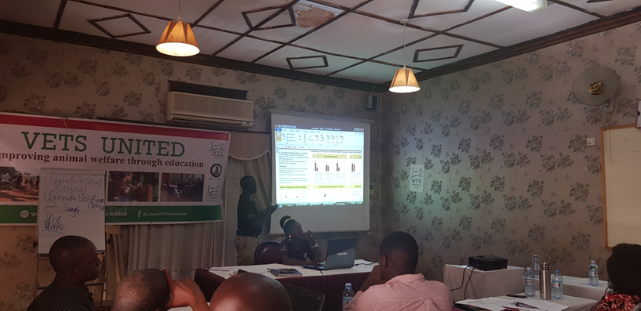Presentation by Dr Ojara Robert
He presented the info-graphic draft which was designed by Natascha and explained the demographic responsiveness of participants to the various questions asked. After the presentation, he observed that the general perception of the participants (ToTs) towards the training and to the instructors seemed to be commendable given the high percentages and numbers of positive acceptances and recommendations.
Picture 2; Showing the Infographic-draft of ToTs.
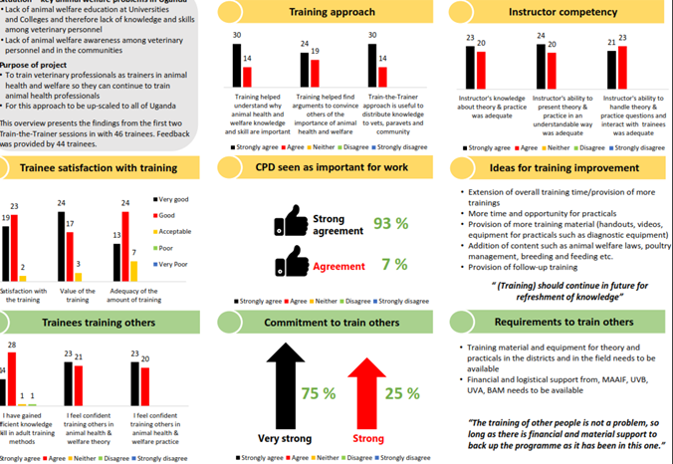

REACTIONS
Mr. Kasango Christopher David; thanked the WTS Vets-United and Bam animal clinics for the CPD program initiative in the country and that many professionals are going to benefit from this training to further equip them with more skills for better management of the animals and consequently improve on production.
Dr Higenyi James; suggested that names should not be included in the next feedback forms, and that Bam should improve on particular practical areas that were of concern to the participants in the next training.
Mr Busulwa Henry; said that DVOs should ensure that participants are vaccinated against rabies so that they may have confidence in dogs and cats handling.
He also added that several stakeholders should be included like the CAOs, DPOs, Lc5s, among others.
Dr Ojara Robert; supplemented that FAO is taking the initiative to support district labs with equipments and so this will help trainees in future.
Dr Tayebwa; suggested that UVA be in touch with MAAIF to provide human vaccines for the vets before they go to the fields and trainings.
The day’s program was closed by the chair of the meeting who thanked everyone for turning up for the meeting and their contributions towards the discussions were highly appreciated.
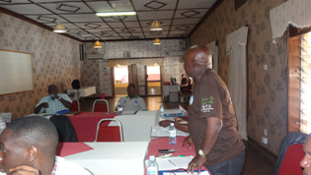
DAY TWO
The chairman BAM lead the members through the prayer.
DVO Mukono led members through the recap of the previous day.
He suggested the recap be a discussion such that members shared their training experiences individually
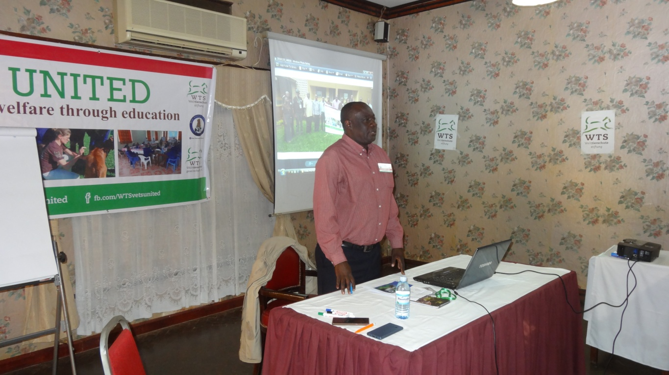
RECAP ~ Dr Were Peter

Dr Ojara Robert; noticed that the MoU had not yet been signed.
He added that after reviewing the logic model and the methodology of the training, bam animal clinics and their project, seemed to be on the real right track.
Dr Tayebwa Dickson; said from the issues raised by the ToTs in the feedbacks, BAM team to clarify on the more number of stakeholders needed for the training, and the logistics that were needed.
He noticed that ToTs suggested that politicians should be involved in the trainings.
He also noticed that ToTs needed more time and materials to facilitate the training.
He also noticed that members wanted to know, to what level are the VPPs supposed to be doing surgeries.
Dr Kagoda Samuel; noticed that members requested Paravets to be changed to Para professionals.
He appreciated the presence of the four ToTs who were invited for the stakeholders meeting.
Mr Kasango Christopher David; noticed that from the feedbacks, ToTs wanted to know more about drug administration since all what is taught goes back to the farmer.
Dr Higenyi James; noticed that the report was tailored to only the funders and suggested that there should be other reports to UVB and UVA.
Mr Busulwa Henry; emphasized numbering of the report pages, in case of mistakes for corrections.
He also noticed that the evaluation process of the participants (the criteria) was very important and professionally designed.
He noticed that stakeholders suggested that names should not be included on the feedback forms of the participants, that it is hard for them to give an authentic opinion.
The key action points noted were;
- MAAIF to come up with a package to cater for animal welfare in disaster.
- Bam animal clinics should be taken higher in MAAIF structure at top management level, aiming at integrating BAM in the ministry’s planning.
Dr Okello David; liked the logic model and noticed that the trainees feedbacks should be looked at more critically and considered during the project implementation process.
Dr Kasadha Mathias; noticed that involvement of politicians was a good idea and should be considered for better mobilization.
He added that radios offered programs for animal welfare, so requested Bam animal clinics to utilize them for follow ups and extending knowledge to the community.
Dr Tumwine Gabriel; appreciated the module and requested that animal production should not be left out.
He also appreciated the analysis of the feedbacks and the selection criteria that was presented.
Mr. David Balondemu; thanked everyone for willingly coming to attend the meeting and said that it was his pleasure to have members on board, to correct the mistakes and give appropriate ideas for a better CPD dispensation in the country.

GROUP WORK ON TOPICS AND CONTENTS FOR TRAINING OF TRAINEES.
Lead by DR KALANGE MUHAMOUD AND MR KAGODA SAMUEL.

Mr Kagoda Samuel and Kalange muhamoud requested members to make groups and suggested that at least each group should consist of one ToTs representative to discuss the modules and contents to be trained and requested members to come up with modules that suit the trainees, and suggested priorities be from the 7 modules, what should be included and what is thought to be important.

PRESENTATION OF GROUP WORK
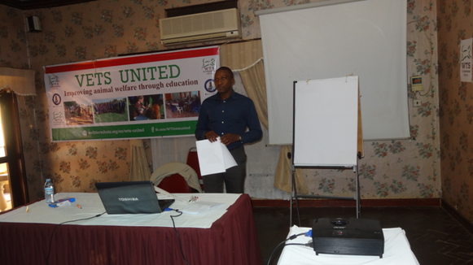
Presentation by DR Tayebwa Dickson

GROUP ONE
Was represented by Dr Ouma joseph
Suggested that module 1 should be maintained and that it should include;
- Introduction to animal welfare
- Definitions and emphasize care, handling and compassion
- The five freedoms, among others.
Module 2 also maintained and include;
- Management of animals in pain,
- Animal comfort and
- Animal signals.
- Module 3 also maintained and include;
- Animal welfare during transport,
- The DOs before, during and after transportation and,
- Mode of transport.
- Outreach should be involved, field practices and quiz.

GROUP 2
Suggested that the following modules should be maintained;-
Module 1 should include;
- Introduction to animal welfare
- Definitions
- History of animal welfare
- The five freedoms
- The 3Rs, among others.

Module 2
Should include economic implications on a case based approach.
Module 3 Should include;
- Clinical examination
- Sample collection and drug administration.
Module 4, legislation should be included.
Module 5,
- Should include transport and slaughter
- Emphasize OIE standards, the effects on movement and quality.
Module 6,
Include adult learning skills since they are big people.

GROUP 3
Represented by Dr Kasadha
Also suggested that the following modules should be maintained;
Module 1
- Should include introduction to animal welfare
- Definitions
- Emphasis on care, handling and compassion
- The five freedoms
- Practicals
And suggested that all the sessions should take a maximum of 8hrs.

GROUP 4
Represented by Dr Were Peter
Also considered time as the first priority,
Planned for 3hrs-theory
3hrs -discussion and
2hrs -practicals.

Group 4 suggested that all modules1, 2, 3, 5 and 6 were necessary and should be talked about briefly.
Legislation and enforcement should also be talked about.
Time allocated for each module was as follows;-
- Module 1- 30 mins
- Module 2- 45 mins
- Module 3- 30 mins
- Module 5- 30 mins
- Module 6- 30 mins
- Legislation- 15 mins, giving a total of 3hrs
- Practicals to include module 2 and 3 for 1:30mins
- Visual -30 mins
Dr Tayebwa requested that we merge all the points such that they match one day.
Time considered was;
Start at 9am and end at 4pm i.e 3hrs &30mins in the morning and 3hrs in the afternoon.
Lunch and health breaks were also considered.

CONCLUSIONS:
Dr Higenyi; suggested that morning sessions should be for theory and in the afternoon, 1hr theory and 2hrs for practical.
In Conclusion, 4hrs &30mins theory and 2hrs practicals.
Agreed modules to be included;-
Module 1 for 1hr,
Module 2 should be extended to the practical session with clinical examination.
Module 3, practical and animal diseases should also be included in this module.
Module 5, for 1hour and
Module 6 for another hr.
Transport and slaughter should be combined within 1hr.
Members suggested that legislation, cruelty, diseases and their prevention should be included in the 1st session
They also suggested that communication skills should be talked about at the time of the video session.
A table was finally drawn to show the summary of the course content to be delivered to the trainees.
Table 2: Showing the course content for trainees
TIME | MODULE | CONTENT
9:00am-10:00am | Module 1 | Concepts and principles of animal welfare, Definitions, history of animal welfare, five freedoms, 3Rs, relationship between animal welfare and productivity.
10:00am-10:30am | Health break
10:30am-11:30am | Module 5 (Theory) | Transportation, OIE and national standards, effects of non-compliance with transportation standards of live animals.
11:30am-12:30pm | Module 6 (Theory) | Slaughter, international standards, national standards, effects of non-compliance on live animals and meat, compliance enforcement.
12:30pm-1:00pm | Discussion | All modules
1:00pm-2:00pm | Lunch
2:00pm-3:00pm | Lecture on legislation | Emphasis on those related to animal welfare such as cruelty, animal disease Act, communication skills
3:00pm-5:00pm | Practicals  (Module 2 & 3) | Outreach, Clinical examination, animal handling, management of injuries and diseases,  Infrastructures and biosecurity

BEST WAYS TO IMPROVE ANIMAL WELFARE CPD TRAININGS ON A LONG TERM IN UGANDA.
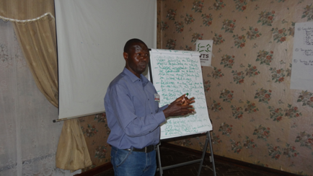
DR OJARA ROBERT
Dr Ojara referred to the program presentations and said that members can use it to develop points to improve animal welfare CPD trainings in the long run.
Dr Kanakulya suggested that each member should write down points on paper to be read to the group and he was seconded.
Points were raised and read by Mss Fatuma Naiwumbwe.

Best ways to improve animal welfare CPD trainings on the long term
- Make a training handbook ~ Manuals
- Trainings should be more of practicals (hands on)
- Segregate trainees according to their levels of qualification to tailor the training.
- Training of trainers approach is relevant
- Direct involvement of the regulatory body in the planning and implementation of the program.
- Support from responsible persons (UVB) to BAM
- Compile documentary on animal welfare scenarios in Uganda to meet up to date trainings by BAM.
- Continuous backstopping of DVOs.
- Beef up trainings with relevant guidelines.
- Leverage on radio program slots.
- CPD trainings should be institutionalized by UVB, UVA AND UVPPA
- Livestock sector should include CPD in district work plans.
- MAAIF to lead in bringing on board all stakeholders involved in the CPD trainings.
- Use of visual aids (local videos and examples)
- Avail more time for the training
- Convene the currently graduated ToTs into national trainers to reduce the load on the current trainers of Bam.
- More emphasis on the active participation of the trainees
- Presentations related to the improvement of the trainees work responsibilities
- Feedback forms should be anonymous
- Liaison of government with DVOs for selection of trainees
- Feedback focal person located at BAM desk to share success and follow up M&E
- Share reports with key stakeholders to edit
- Increase on the training time
- Continuous trainings in year focussing on different topics depending on the needs
- Needs assessment should be conducted by BAM management and training gaps identified for future trainings
- Relating animal welfare and animal health and production
- All trainees should be registered with UVB and other associations prior to training
- Proper mobilization
- Identifying people with interests in the program
- Well facilitated trainers
- UVB to develop guidelines for the trainings
- Encourage other stakeholders and service providers on CPD trainings
- UVB should sensitize veterinarians on the need to have CPDs
- COVAB, UVB and other training institutes should include CPD philosophy in their curriculum
- Consult OIE to provide guidelines for the training
- CPDs points should be allocated
- Establish an incubation hub for animal welfare trainings at Bam headquarters so many interested learners can come and train at the facility.
- Disseminate information on CPD through various platforms e.g. media, print and electronic.

REACTIONS AND DISCUSSIONS;
Members wanted to know who was to be responsible for the Documentary, since it required more of finances.
Dr Higenyi James suggested that documentary should be put on bam animal clinics as its outputs, to show exactly what is happening in Uganda and urged that members should share experiences of videos and pictures taken at the end of the CPD trainings.
Dr Kanakulya advised bam animal clinics to put up an incubation hub to avoid high costs of moving everywhere in the country to train, trainees could then come for training at Bam on schedules. The hub can have several species of animals for hands on practical trainings.
Dr Kalange added that grants on capacity building are provided by the ministry at the districts so DVOs could also utilize this for future CPDs.
Dr Ojara urged DVOs to share information to other stakeholders such as LC5s and CAOs at the district for their involvement.
He added that it is very important to involve politicians for mobilization and trainings.
Dr Kanakulya wanted to know how CAOs and other members can be helped to buy-in issues about animal welfare.
Mr Busulwa replied that it is the DVOs responsibility to share animal welfare legislations with CAOs and LC5s.
Dr Ojara urged that members should emphasize getting enough information and share it with the relevant personnel.
He summarised the key points raised as follows;-
- Planning very important for sustainability of the project.
- Logistics needed ie finances and more training materials.
- UVB involvement is very necessary.
- Progress reports should be provided always
- Needs assessment quite important
- Relating animal welfare to peoples income was very crucial
- Methodology being updated to suit the trainings.
- The selection criteria and time for training was also important.

DISCUSSIONS ON HOW TO ALLOCATE CREDIT POINTS BASED ON OUR TRAINING.

Dr Dickson informed members that UVB is responsible for accrediting the credit points and that, we should wait for their accreditation process then be informed of how to credit our trainees as well.

SIGNING OF MoU
Members observed that the process involves a lot of bureaucracy including lawyers and the Antony general of government, However , concurred that BAM management should look forward to signing this agreement since it was a requirement of the Donor.
Dr Ojara suggested that Bam should write a letter to the PS, MAAIF through UVB, the CAH and the ACVRE that this will help in the Signing of MoU

CLOSING REMARKS
Chairman Bam animal clinics, Mr Kasango Christopher David thanked all members for participating in the meeting.
Thanked Bam animal clinics management, special thanks to the director and the WTS Vets-United in particular, for the arrangements. He urged members to continue participating in such meeting and special thanks to the almighty God for the protection and guidance throughout the meeting.
The director Bam animal clinics urged members to continue spreading the gospel of animal welfare and once again thanked everyone for attending the meeting, and urged that they should always turn up when called upon for better and proper guidance of the project.

APPENDIX I

ISSUES AND SUGGESTIONS FROM PARTICIPANTS DURING THE TOTs TRAINING
(Source; feedback forms by Natascha, WTS)
- Need to involve other components like breeding.
- Need for more training materials e.g videos, photos, microscopes among others for practical sessions.-
- Involvement of several key stakeholders in the training
- Need to provide more training materials at districts for the trainees to continue practicing.
- Bam animal clinics needs to be equipped with all the necessary equipments for the training as some centers do not have the equipments for the training
- Involvement of politicians e.g CAOs to be done by bam animal clinics for effective implementation and smooth running of the program
- Some of the materials used for demonstration during the TOTs are not available at districts when it comes to decentralized training of trainees
- Drug administration and handling needs more refresher training.-.
- The training contents required more time than the 3 days allocated for the better understanding of the concepts-
- Training at trainee’s level should still be backstopped by bam animal clinics-
- More Facilities for proper handling should be provided stakeholders
- More E charts be provided for practical trainings-
- Need to provide sessions for participants to share personal experiences and/ or brainstorm hypothetical scenarios in respect to field experiences
- Widen the scope of animal species to be trained on like pigs, poultry, cattle, sheep, goats, rabbits, donkeys, camels, among others
- Time lag between training of TOTs and training of trainees should not be so long as they may tend to forget
- Need to improve on the diagnostic tools and More visual aids need to be provided
- More logistics needed to facilitate the trainings
- Need for backstopping in the districts by bam animal clinics team
- Training of trainees requires power point projectors and all other necessary materials at the centre of training.
- Needs for more training of this type to improve on the participants experience and knowledge
- Need for more elaboration about the laws and penalties for breach of animal welfare regulations.
- More knowledge on dogs and cats handling needed.
- Information about the relationship between animal welfare and productivity should be provided
- History of animal welfare be cited i.e how it started.
- More emphasis and elaboration on clinical examination needed
- Temporally laboratories to be set up at training venues and participants should have hands on fecal, blood sample collection and examination.
- Laboratory materials and equipments needed at the district so that trainees are able to practice after the trainings
- More technical support from the facilitators needed by the trainers of trainees.( TOTs)
- More CPDs needed in other places across the country.
- More areas should be incorporated in the training in addition to animal welfare e.g new technologies.
- Create a session where participants share with other stakeholders incidences where animal freedoms have been violated in the respective areas.
- More surgical kits be provided and protective gear for dog handling and restraint
- More skills and trainings needed in handling of dogs and cats especially stray dogs
- More Surgery sessions should be included practically
- Humane handling, slaughter and disposal should be emphasized
- Need for continuous follow ups and spreading the same knowledge to other professionals and directly to communities.
APPENDIX II
PARTICIPANTS IN THE STAKEHOLDERS’ MEETING

HELD AT SUNSET HOTEL JINJA FROM 26TH TO 27TH NOV 2019

S/ NO. | NAME | DESIGNATION
 | DR HIGENYI JAMES | ZONE INSPECTOR MAAIF- CENTRAL ZONE TWO
 | DR LALI MUNDRIGO | CHAIRMAN EDUCATION COMMITTEE- UGANDA VETERINARY BOARD(UVB)
 | DR OUMA JOSEPH | EXECUTIVE MEMBER UVA
 | DR OJARA ROBERT | ZONE INSPECTOR MAAIF- SOUTH EASTERN ZONE
 | DR BALONDEMU DAVID | DIRECTOR - BAM ANIMAL CLINICS
 | MR KASANGO CHRISTOPHER | CHAIRMAN BAM ANIMAL CLINICS
 | DR TAYEBWA DICKSON | REPRESENTATIVE FROM COVAB
 | DR TUMWIINE GABRIEL | REPRESENTATIVE FROM COVAB
 | DR KALANGE MUHAMMOUD | BAM FACILITATORS
 | DR KAGODA SAMUEL | BAM FACILITATORS
 | DR WESONGA WANDERA | BAM FACILITATORS
 | DR BALUKA SYLIVIA | PRESIDENT UGANDA VETERINARY ASSOCIATION (UVA)
 | DR BUSULWA HENRY | PRESIDENT UGANDA VETERINARY PARA PROFESSIONAL ASSOCIATION(UVPPA)
 | DR MULINDWA TANANSI | MAAIF REPRESENTATIVE
REPRESENTATIVES FROM THE DIFFERENT ZONES (TOTs)
 | DR KASADHA MATHIAS | DVO MAYUGE- ZONE I
 | DR OKELLO ENYAMU DAVID | DVO KALIRO- ZONE I
 | DR KIRYABWIRE DAVID | DVO MUKONO- ZONE II
 | DR KANAKULYA RONALD.M. | DVO KAYUNGA- ZONE II
BAM SUPPORT STAFF
 | MSS NAKABUYE ROBINA | RAPPORTEUR
 | MR TUSUBIRA MOSES | ACCOUNTANT
 | MSS NAIWUMBWE FATUMA | SECRETARY

Thank you for reading our report
Compiled by; David Balondemu
Director Bam animal clinics.

